Lab Assignment: Calling the NWS API and Displaying Weather Forecasts – Part 1

# Objective:

In this lab, you will implement a Java program that uses the National Weather Service (NWS) API to retrieve and print the next 7 days of weather forecasts. This assignment will reinforce your understanding of HTTP requests.

# Background:

The National Weather Service (NWS) provides an API that returns the weather forecast in JSON format. You will make an HTTP GET request to the NWS API and print the raw weather forecast for the next 7 days (14 forecast periods in total). Each forecast period includes temperature, wind speed/direction, and a detailed weather description.

# Tools:

* **Java Development Kit (JDK)**
* **Chocolatey:** Chocolatey is a package manager and installer for Windows.
* **Gradle v8.10.1:** Gradle is a build tool that simplifies building programs.
* **Insomnia:** API development platform

# Step-by-Step Instructions:

## Step 0: Install the necessary tools

1. If you are using Windows, you will use Chocolatey to install Gradle. If you are using MacOS, you will use Brew to install Gradle.
2. Chocolatey can be found at <https://chocolatey.org/install>.
   1. Follow the instructions to install Chocolatey for Individual Use.
3. Gradle can be found at <https://gradle.org>/install.
4. Install Gradle
   1. For Windows, open a command window and type:

choco install gradle

* 1. For MacOS, open the terminal and type:

brew install gradle

## Step 1: Initializing the directory structure.

* Initialize a Java directory structure using gradle.
  + The image below shows the prompts and responses:

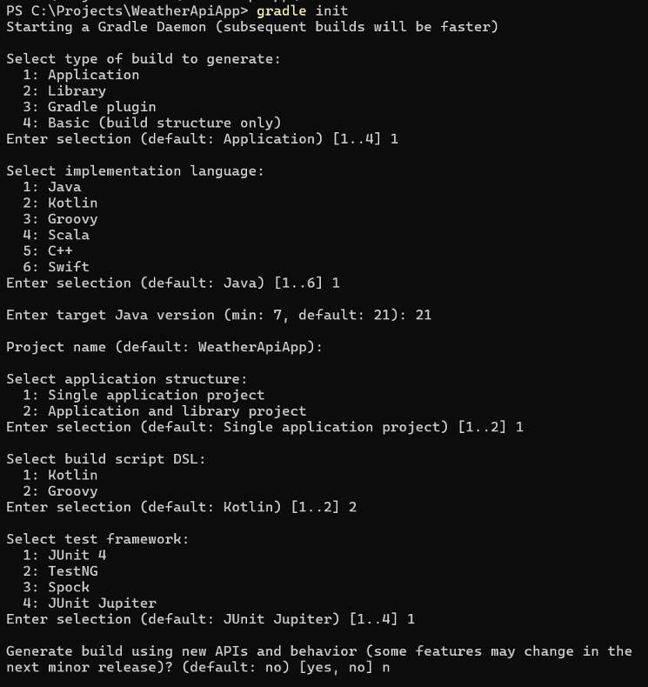

## Step 2: Setup and API Introduction

* **Research the NWS API**:

The NWS API endpoint you’ll be using is:  
https://api.weather.gov/gridpoints/{office}/{grid X},{grid Y}/forecast

Replace {office}, {grid X}, and {grid Y} with appropriate values based on a location you want to query.

**Example URL for Sierra College:** <https://api.weather.gov/gridpoints/STO/53,76/forecast>

View the output of an HTTP request to the Sierra College URI in a browser window or using Insomnia.

**Note:** Visit the [NWS API documentation](https://www.weather.gov/documentation/services-web-api) to learn how to construct a valid API request.

## Step 3: Project Structure

Your project will consist of the following key components:

1. **WeatherForecastApiClient** (Class)
   * This class will handle making an HTTP GET request to the NWS API and retrieving the JSON response.
2. **App** (Class)
   * This will contain public static void main(String[] args).
   * A WeatherForecastApiClient object will be instantiated here.

## Step 4: Implementing the WeatherForecastAPIClient Class

In this class, you will:

* Use the Office and Grid of Sierra College for the request.
* Use HttpClient, HTTPRequest, and HTTPResponse.
* Send an HTTP GET request to the NWS API.
* Return the response.

**Methods to Implement:**

* public String getWeatherForecast(): Sends a request to the API and returns the JSON response as a string.

## Step 5: Implementing the Main Class

The main class will:

* Create an instance of WeatherForecastAPIClient.
* Call getWeatherForecast() and print the results to the console.

## Step 6: Testing the Application

1. Run your program and ensure it prints all 14 forecast periods.

*Good luck, and feel free to ask questions if you need clarification!*